**Javascript Debugging**

**CHROME**

1. Ask the user for his/her name.

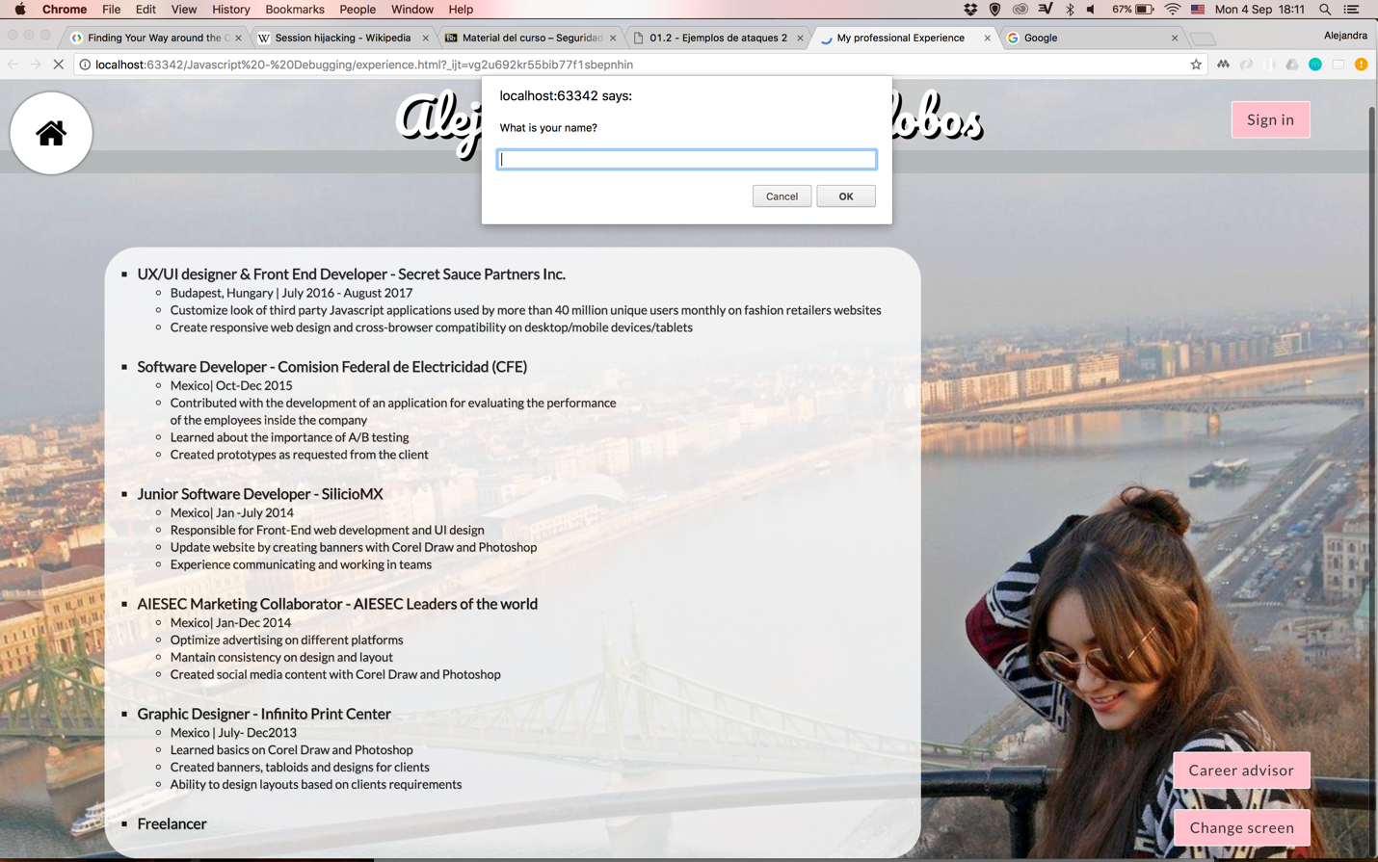

1. Add the current date and time in the main page and a time-sensitive greeting including the user's name.



1. Add a button to enable the user change the background color of the page

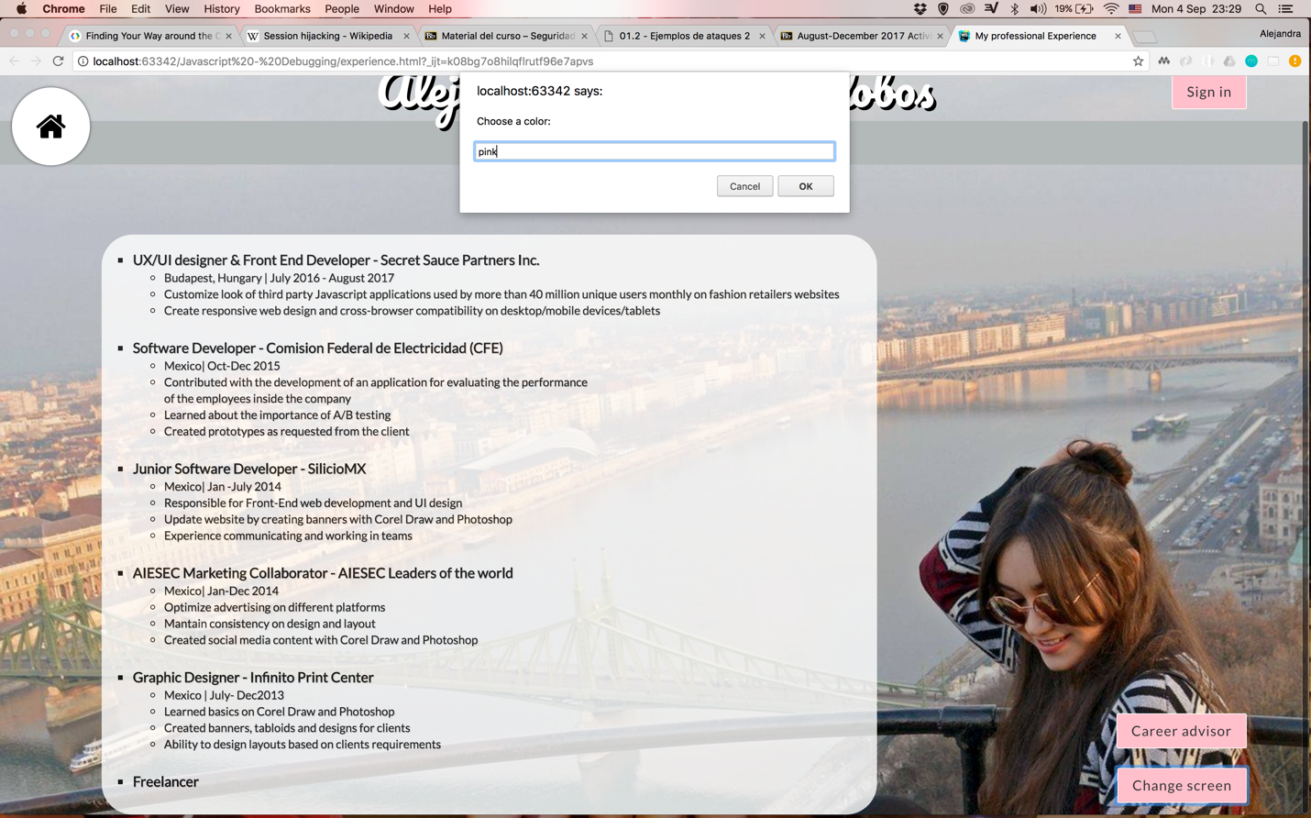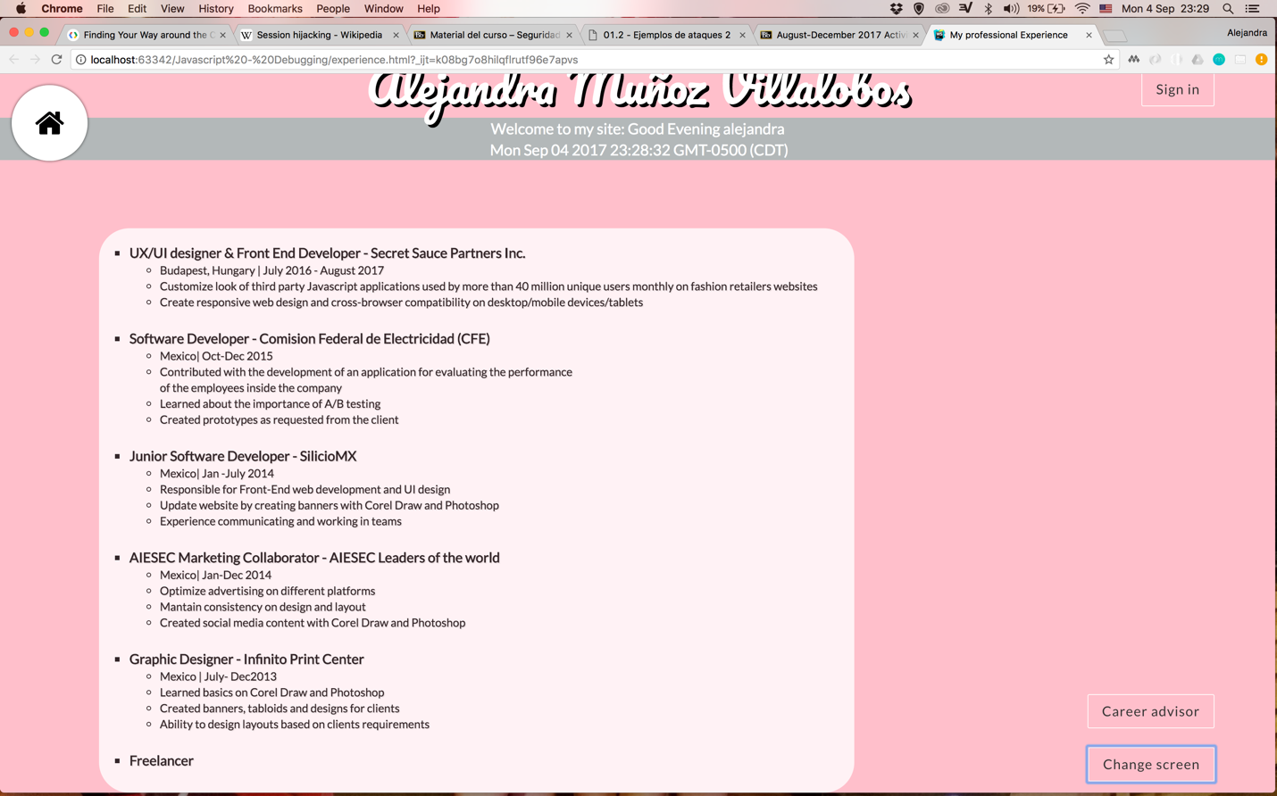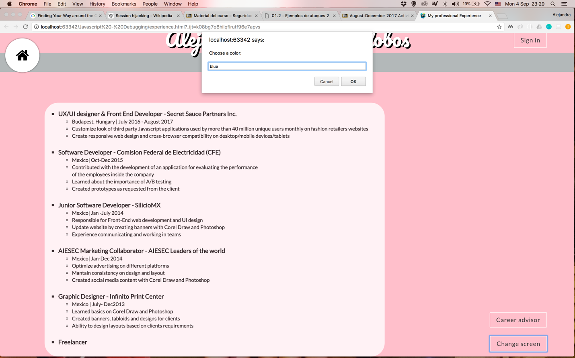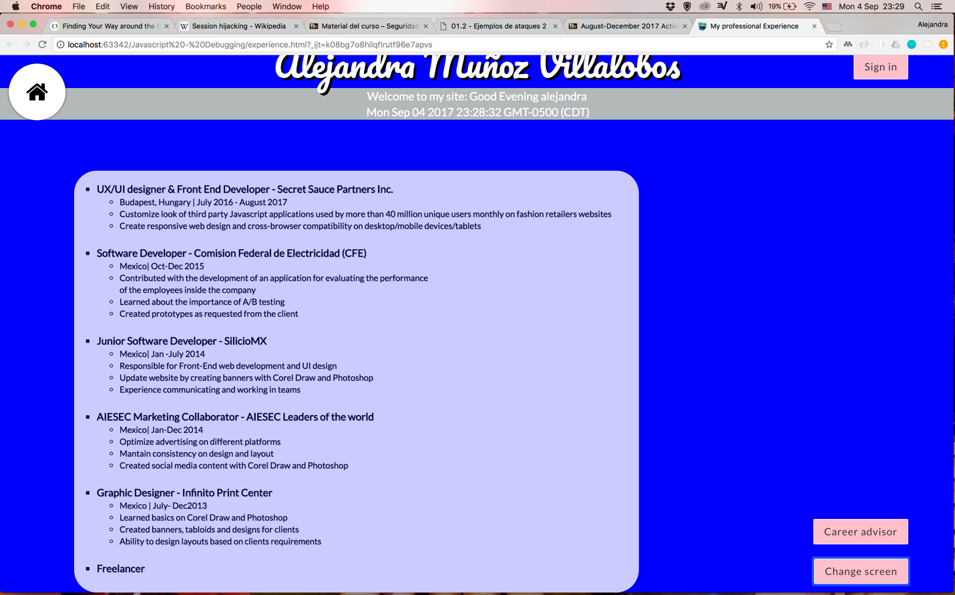

1. Show in a window the name of your career advisor when a button is pressed.

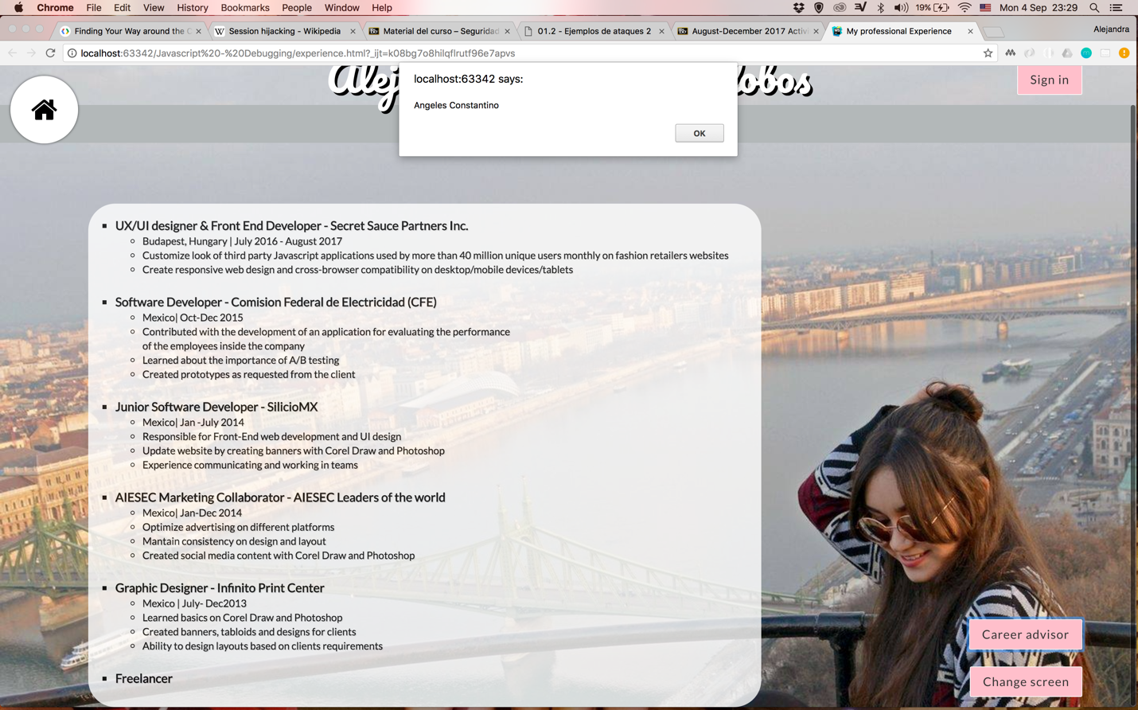

1. Change the color of your name when the mouse is over it.

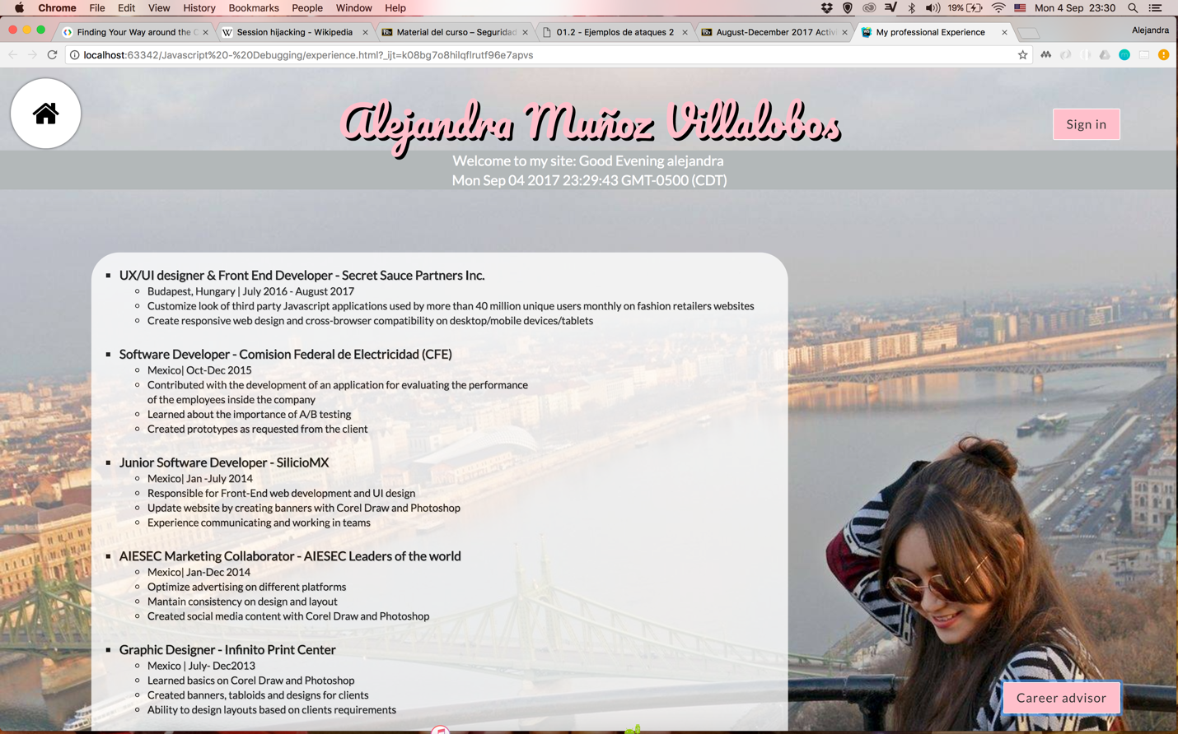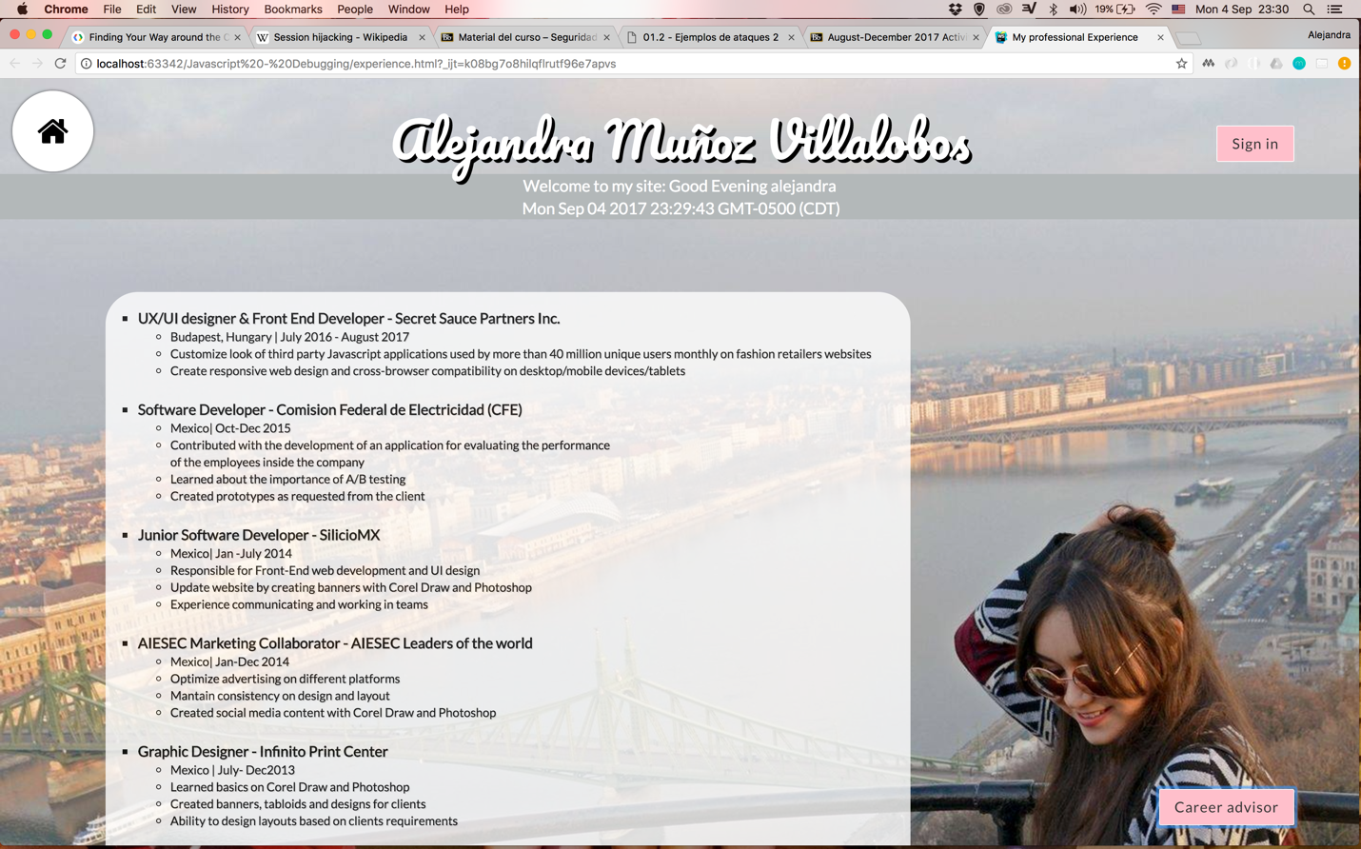

**FIREFOX**

1. Ask the user for his/her name. 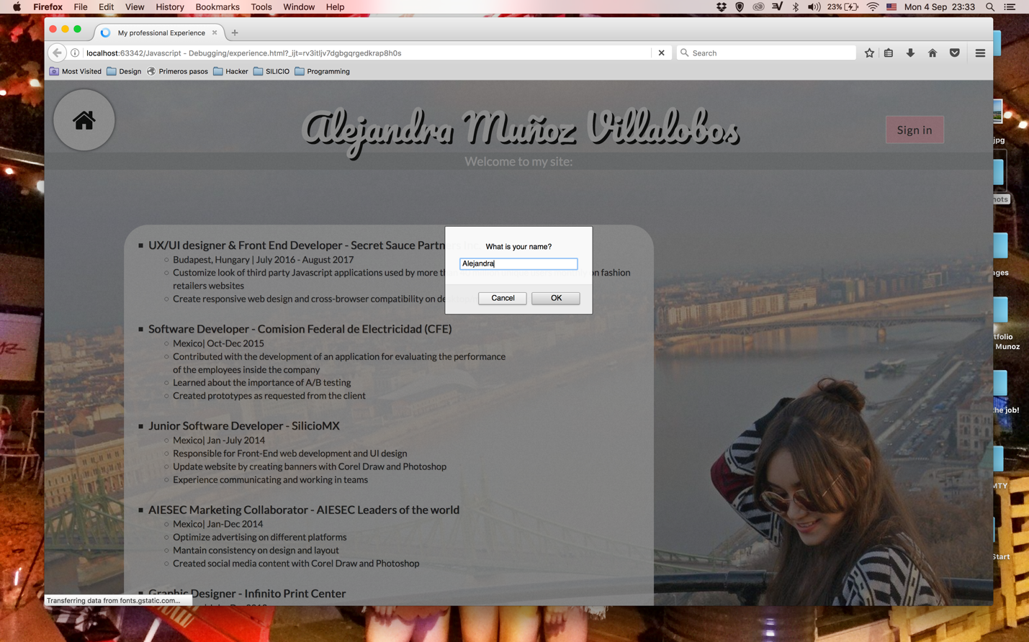
2. Add the current date and time in the main page and a time-sensitive greeting including the user's name.



1. Add a button to enable the user change the background color of the page

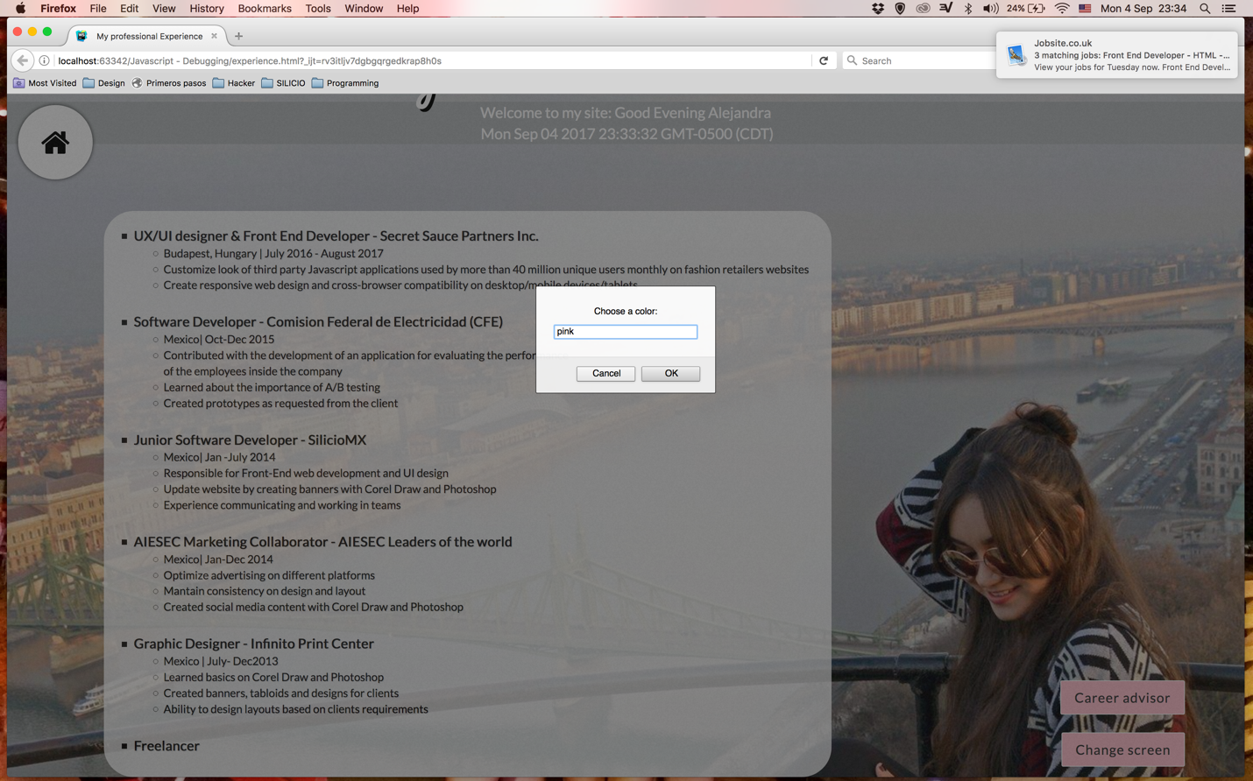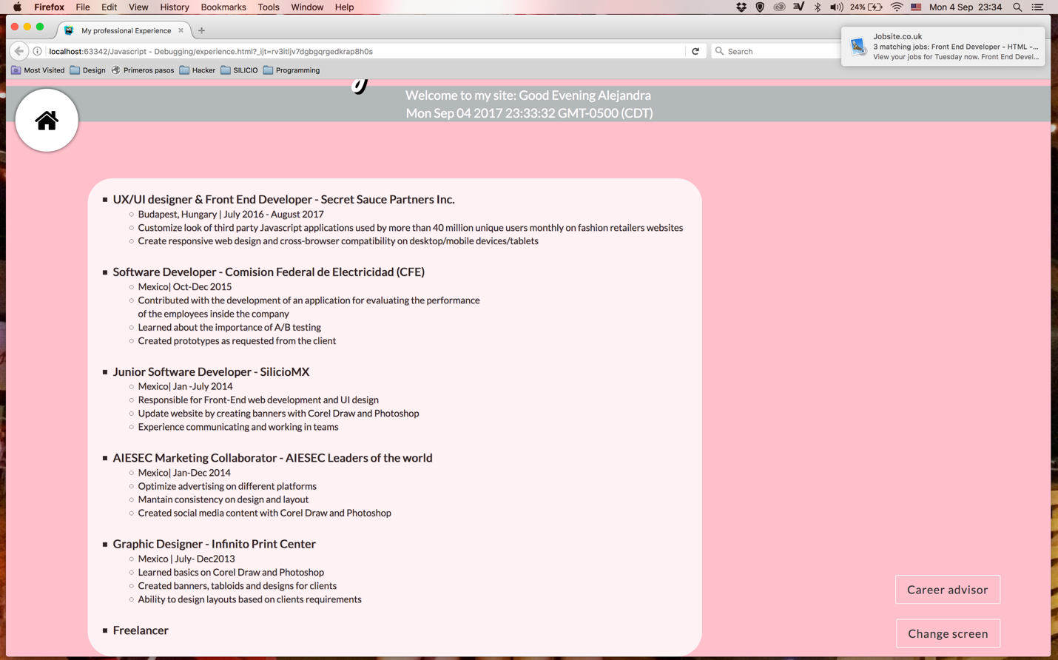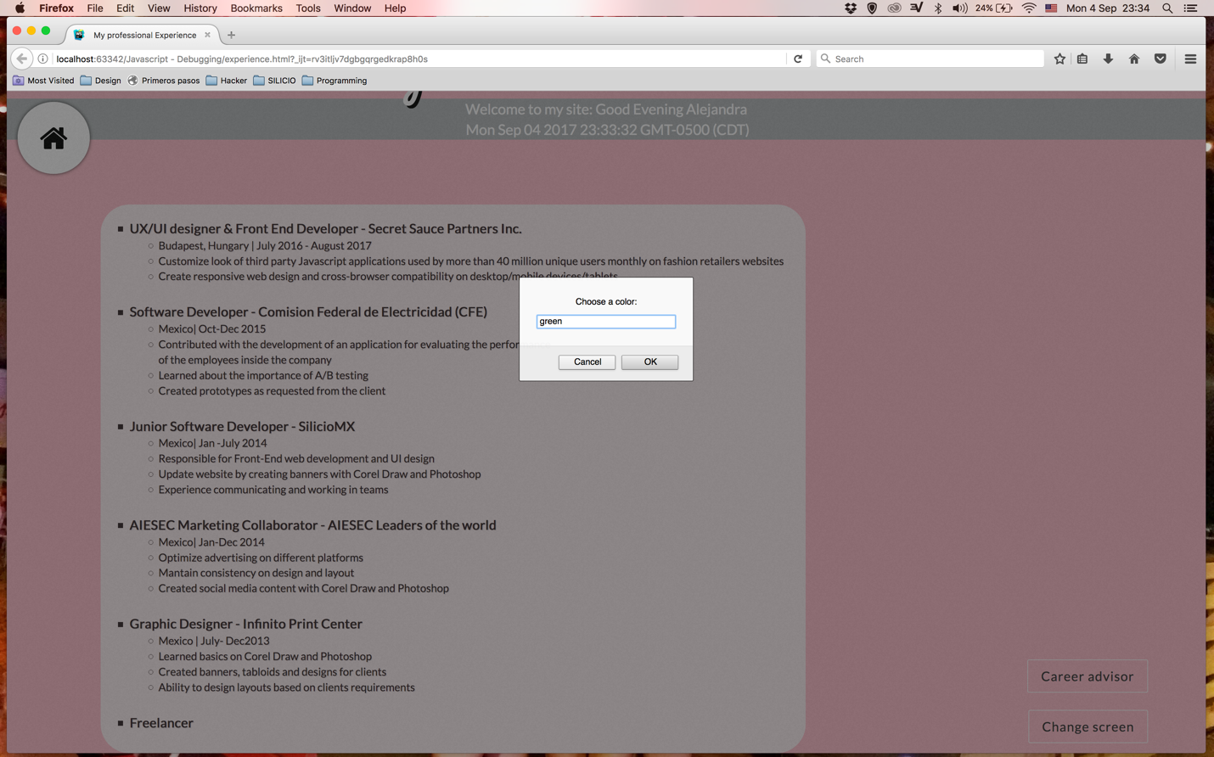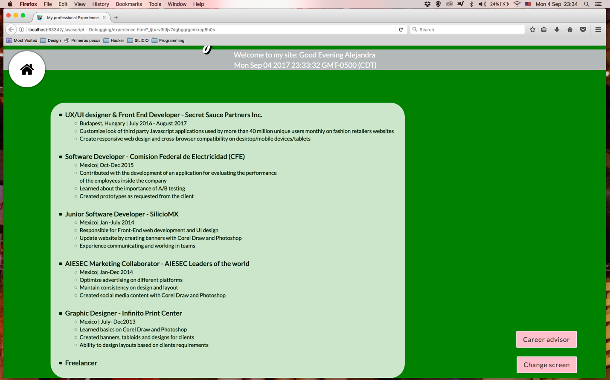

1. Show in a window the name of your career advisor when a button is pressed.

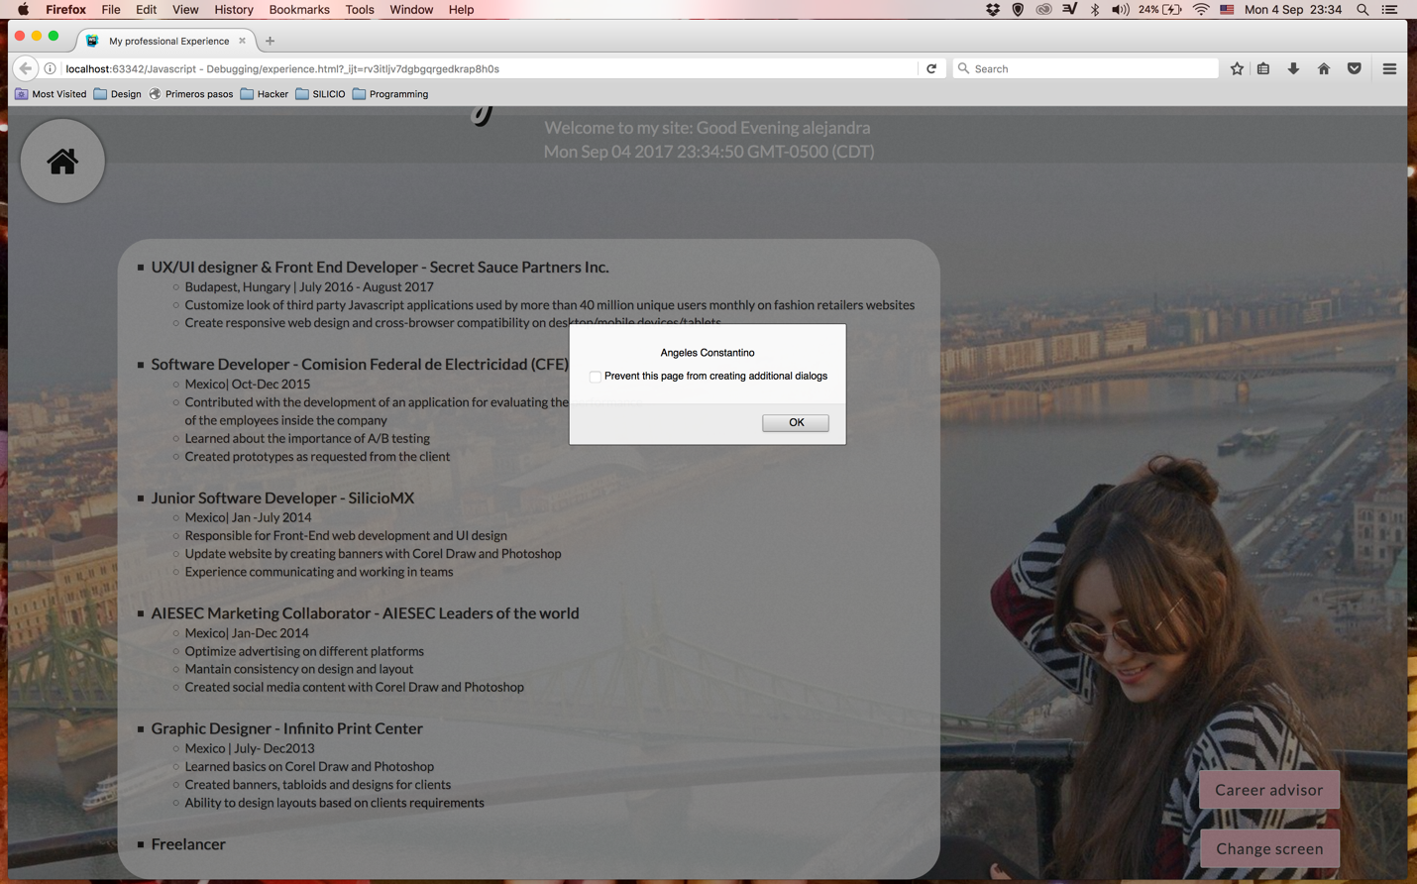

1. Change the color of your name when the mouse is over it.

